1. The following char is weekly which means higher the timeframe, the higher is the possibility that the trade will work in our favour.
2. 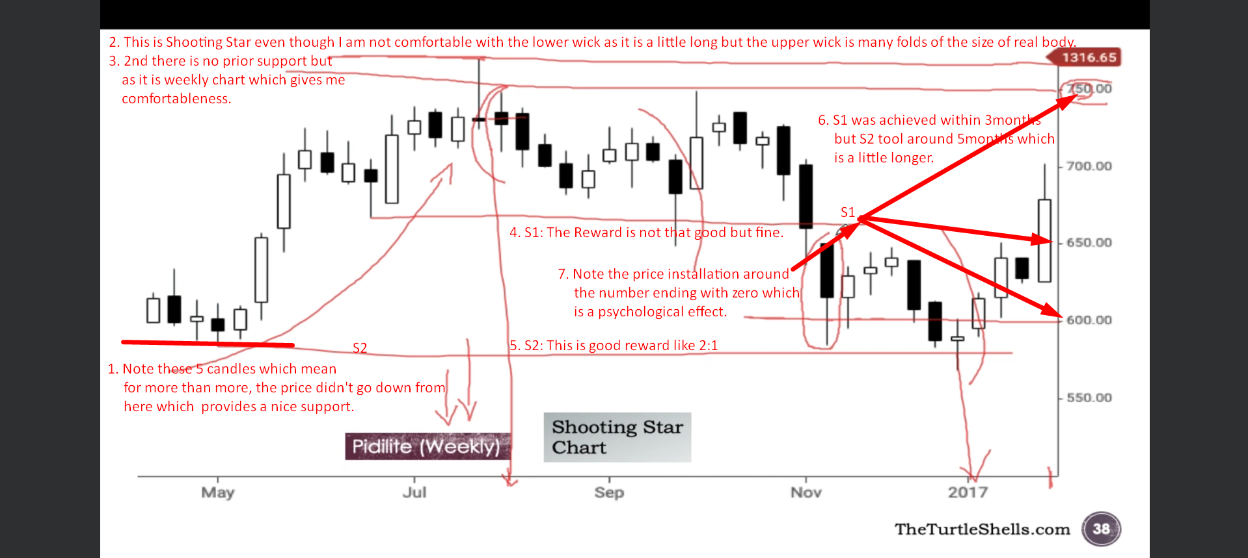  
   **NOTE**: The upper high of the Shooting Star becomes the nice resistance as none of the candle after it can break the resistance.   
   **NOTE**: This is aggressive trade as there is no prior resistance.